Project 25 — Evidence Guard: Complete Project Document
Oct 25, 2026 · @Shanteshwar

1. Project at a glance
Evidence Guard is a web platform that keeps cybercrime evidence tamper-evident with SHA-256 hashes and a permissioned blockchain, and uses AI to classify, connect and monitor that evidence, with every AI result recorded on the same audit trail.
This document merges three inputs: the original study document (research, gaps, objectives), the suggested implementation plan (stack, milestones, datasets), and the 10 UI screens you shared. Where the plan and the study document differ, the plan's practical choice is used and the study document's alternative is noted. Everything in the plan is a suggestion, not a requirement.
Item | Summary
Title | AI-Assisted Blockchain-Based Cybercrime Evidence Integrity Management System (UI brand: Evidence Guard)
Project number | 25
Domains | Artificial intelligence, blockchain, cybersecurity, digital forensics
Problem | Digital evidence is easy to alter unnoticed, passes through many hands, is tracked on paper or in editable spreadsheets, and comes in volumes too large to review manually
Solution | Hash every item (SHA-256), encrypt it (AES-256-GCM) and store it off-chain, record custody events and AI results on a permissioned ledger, and gate every AI run behind an integrity check
Three pillars | Cybersecurity (protect the evidence), blockchain (maintain the history), AI (help investigate)
Users | Investigating officers, forensic analysts, prosecutors, courts, auditors
Legal support | Hash and custody reports mapped to BSA 2023 Section 63(4) fields; no automatic certification, no claim of court acceptance
Data | Public or synthetic only; no real case data or personal data
Timeline | 14 weeks, three milestones
What blockchain does and does not do. It makes registered evidence and its history tamper-evident, meaning changes are detectable. It does not prove the evidence was collected correctly, and it does not prove the AI's conclusions are true. State this limitation in every report and in the final presentation.
Research contribution to emphasise. The evidence, the record of who handled it, and the AI analysis are connected in one auditable workflow. Most existing work covers only blockchain custody or only AI analysis.

2. Problem and solution
Digital evidence can be changed without a visible trace, so a case can be weakened by a single disputed handover. The system answers six questions an investigator must be able to answer with proof.
Why evidence is fragile
- It is easy to edit, copy or delete without visible traces unless integrity controls exist.
- Many people handle it between seizure and court, and each handover can be disputed.
- Custody is still often tracked on paper forms or spreadsheets that privileged users can alter.
- Volume is huge: a single case may hold thousands of emails, logs, screenshots and downloads.
- If custody cannot be shown to be unbroken, evidence may be challenged or excluded.
Questions the system must answer
- Is this file exactly the one originally registered?
- Who accessed it, and when?
- Was it transferred to another investigator properly, and why?
- Which emails, IPs, accounts or people are connected across files?
- Did someone download hundreds of files at an unusual time?
- Can we explain why the AI flagged an item, and can another authorised person verify the result?
Problem statement. Current practice cannot give investigators, courts and defence a verifiable, tamper-evident record of who handled digital evidence and what was done to it, and cannot cope with the volume to analyse. Blockchain-only systems secure custody but do not help analysis; AI-only tools help analysis but their outputs are not provenance-tracked or explainable enough for legal scrutiny.
Why combine the technologies
Need | Blockchain alone | AI alone | Combined
Prove a file was not altered | Yes | No | Yes
Prove who handled it and when | Yes | No | Yes
Handle large volumes | No | Yes | Yes
Find links between evidence items | No | Yes | Yes
Make AI output auditable and reproducible | Not applicable | Weak | Yes: model, version, input hash, output hash and reviewer are anchored
Detect suspicious handling | Fixed rules only | Yes | Yes: anomalies computed over ledger events
Why the file is not on the blockchain. Large files are costly on-chain, evidence often holds personal data that should not be replicated to every node, and ledger entries cannot be deleted while legal retention rules may require deletion. The accepted pattern is hash and metadata on-chain, encrypted file off-chain.

3. Product walkthrough
The product works as a digital evidence locker, an investigation assistant and an audit system, in one six-step journey.
Step | What happens | Where it appears in the UI
1. Upload | Investigator uploads a file and enters case ID, evidence type, source, collector and acquisition details | Evidence Upload (3-step wizard)
2. Fingerprint and encrypt | Backend computes SHA-256, encrypts with AES-256-GCM, saves to off-chain storage | Evidence Details: hash, encryption, storage location
3. Register on blockchain | Ledger records hash, metadata hash, storage reference, timestamp, responsible identity | Evidence Details; Chain of Custody timeline
4. Run AI analysis | After the integrity check passes, AI analyses a copy: classifies, extracts entities, suggests links | AI Analysis Results
5. Review and investigate | Analyst checks AI results, confidence, explanations and timeline, then accepts or rejects with a comment | AI Analysis; Relationship Graph; Security and Anomaly Alerts
6. Verify and export | Authorised user re-verifies integrity, inspects custody history, downloads reports | Verify Integrity button; Reports and Export
Worked example for the demo. An investigator uploads suspicious_email.eml to case CYB-2025-014.
- The system computes its SHA-256 fingerprint and encrypts the file into MinIO.
- The ledger records the hash and registration details.
- The AI extracts email addresses, names, URLs and dates, and classifies the email as phishing with a confidence value.
- The dashboard shows that the email shares an address or URL with other evidence items.
- The analyst accepts or rejects the AI suggestion; the decision is recorded.
- If someone later edits the stored file, verification fails, the item turns to Failed Integrity, and an alert is raised.
An AI relationship is a lead to investigate, not proof of guilt. This example is the end-to-end scenario the final demo should follow.

4. Users and roles
Five roles use the platform, and permissions must differ by role: for example an analyst cannot seal a case, and a viewer cannot register or transfer evidence. The matrix below is a proposed starting point from the study document's chaincode caller rules; confirm it with your supervisor.
Role | What they get | Register evidence | Transfer custody | Verify integrity | Run or review AI | Seal case | View audit and reports
Investigating officer | Register evidence, manage cases, follow custody | Yes | Yes (if current custodian) | Yes | View | No | Yes
Digital forensic analyst | Verify files, inspect AI findings, investigate relationships | No | No | Yes | Yes (accept or reject) | No | Yes
Prosecutor | Review evidence history, prepare supporting documents | No | No | Yes | View | Yes | Yes
Court or judicial officer | Inspect recorded history and verification reports | No | No | Yes | View | Yes | Yes
Auditor | Check access events, user actions, integrity checks, compliance | No | No | Yes | View | No | Yes
Two more identities exist that are not human users: the AI service identity (anchors AI results and flags anomalies) and the system identity (automated events such as the integrity check). Keep them separate from human users so logs show who did what.
The sidebar in the UI has a Users and Roles page and a Settings page, but neither screen was in the mock-ups; see section 5 for the extra screens to design.

5. Final UI: the 10 screens
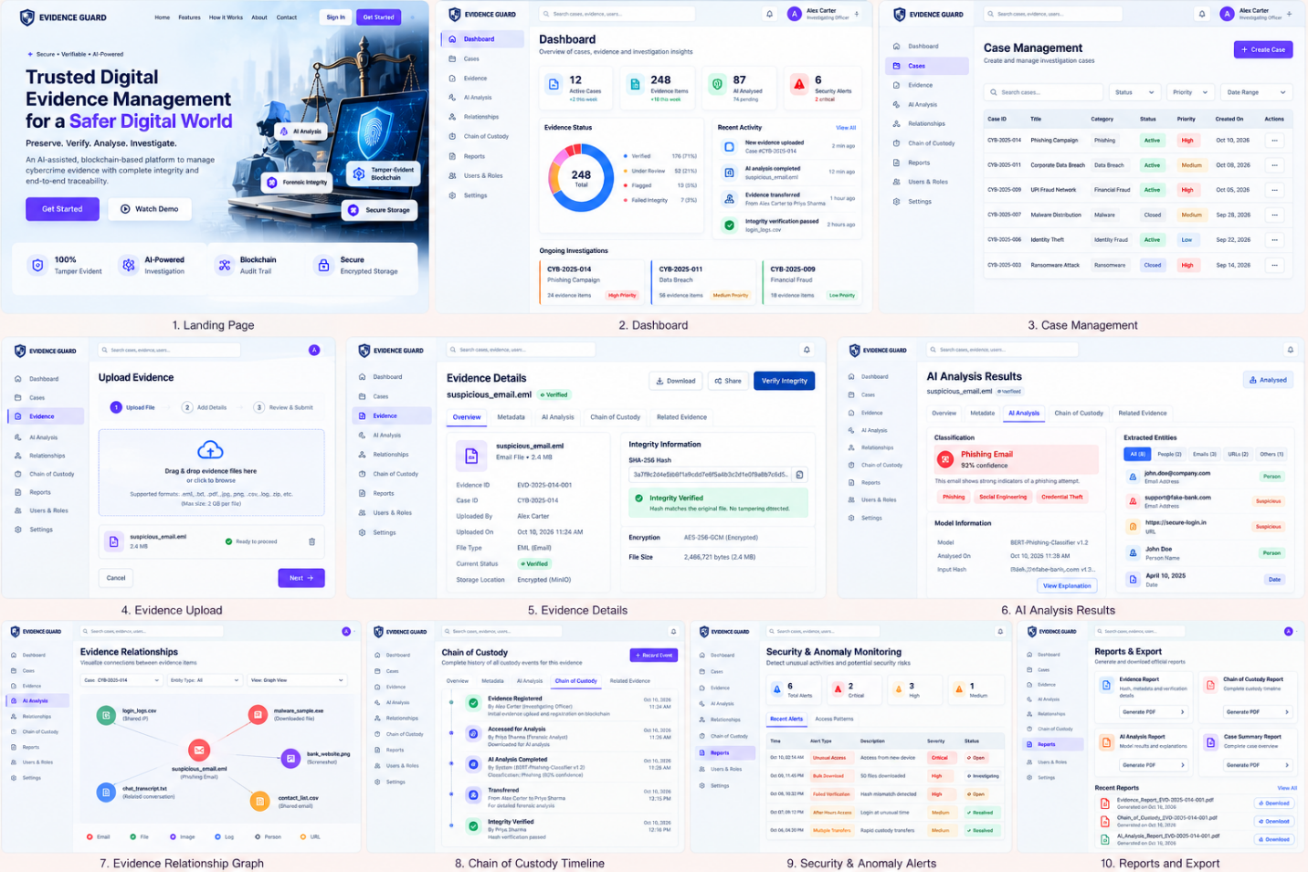

5.1 Shared look and layout
- Style: clean enterprise dashboard, white background, deep indigo or blue primary buttons, rounded cards, soft borders, small coloured status chips.
- Shell: left sidebar with the Evidence Guard shield logo and nine items: Dashboard, Cases, Evidence, AI Analysis, Relationships, Chain of Custody, Reports, Users and Roles, Settings. The active item is highlighted. Top bar has a global search (cases, evidence, users), a notification bell, and the user's avatar, name and role (example: Alex Carter, Investigating Officer).
- Status colours: green = verified, resolved, active; amber or orange = under review, medium, high priority; red = flagged, failed integrity, critical; grey or blue = closed, informational.
- Evidence status values: Verified, Under Review, Flagged, Failed Integrity.
- Alert severity values: Critical, High, Medium (Low also appears on cases).

5.2 Screen-by-screen specification
# | Screen | What it shows | Main actions | Data and backend it needs
1 | Landing page | Hero: "Trusted Digital Evidence Management for a Safer Digital World", tagline "Preserve. Verify. Analyse.", badges (AI Analysis, Forensic Integrity, Tamper-Evident Blockchain, Secure Storage), four value cards (100% Tamper Evident, AI-Powered Investigation, Blockchain Audit Trail, Secure Encrypted Storage). Top nav: Home, Features, How It Works, About, Contact | Sign In, Get Started, Watch Demo | Static marketing content; auth entry
2 | Dashboard | KPI cards: Active Cases (12), Evidence Items (248), AI Analysed (87, 74 pending), Security Alerts (6, 2 critical). Evidence Status donut (Verified 176, Under Review 52, Flagged 13, Failed Integrity 7). Recent Activity feed. Ongoing Investigations cards with case ID, title, item count, priority | View All activity, open a case | Aggregated counts from PostgreSQL; recent ledger events; alert counts from anomaly module
3 | Case Management | Table of cases: Case ID, Title, Category, Status, Priority, Created On, Actions menu. Filters: search, Status, Priority, Date Range. Example categories: Phishing, Data Breach, Financial Fraud, Malware, Identity Fraud, Ransomware | Create Case, filter, open or manage a case | Case CRUD; role checks; statuses Active and Closed
4 | Evidence Upload | 3-step wizard: Upload File, Add Details, Review and Submit. Drag-and-drop area, supported types (.eml, .txt, .csv, .json, .png, .jpg, .log and others), max size 2 GB, file card with Ready to proceed | Browse, Next, Cancel | Chunked upload, SHA-256 and AES-256-GCM on backend, then register on ledger
5 | Evidence Details | Header with file name and Verified chip. Tabs: Overview, Metadata, AI Analysis, Chain of Custody, Related Evidence. Overview: Evidence ID (EVD-2025-014-001), Case ID, uploaded by, uploaded on, file type, status, storage location (encrypted, MinIO). Integrity Information: SHA-256 hash with copy button, green Integrity Verified banner, encryption AES-256-GCM, file size | Download, Share, Verify Integrity | Evidence record, ledger status, live hash recomputation
6 | AI Analysis Results | Classification card: Phishing Email, 92% confidence, short reason, tags (Phishing, Social Engineering, Credential Theft). Model Information: model name and version, analysed on, input hash. Extracted Entities panel with tabs All, People, Emails, URLs, Others and items marked Person, Suspicious, URL, Date | View Explanation, tabs | M1 and M2 outputs, model version, input hash, SHAP or highlight explanation
7 | Evidence Relationship Graph | Filters: Case, Entity Type, View (Graph View). Central evidence node linked to related items (login logs, malware sample, bank website screenshot, chat transcript, contact list). Legend by type: Email, File, Image, Log, Person, URL, with edge labels such as Shared IP, Downloaded file | Filter, zoom or click nodes | Graph from NetworkX relationships, node and edge types
8 | Chain of Custody | Vertical timeline for one evidence item: Evidence Registered, Accessed for Analysis, AI Analysis Completed (with model and result), Transferred (from, to, reason), Integrity Verified. Each event has actor, role, timestamp and ledger link. Same tab set as Evidence Details | Record Event | Ledger history via GetHistory; transaction IDs
9 | Security and Anomaly Alerts | Counters: Total, Critical, High, Medium. Tabs Recent Alerts and Access Patterns. Table: Time, Alert Type, Description, Severity, Status (Open, Investigating, Resolved). Types shown: Unusual Access, Bulk Download, Failed Verification, After Hours Access, Multiple Transfers | Open alert, change status | M3 anomaly detector output with reasons
10 | Reports and Export | Four report cards: Evidence Report, Chain of Custody Report, AI Analysis Report, Case Summary Report, each with Generate PDF. Recent Reports list with Download links | Generate PDF, Download | Report generator (hash report, custody report, AI provenance, Section 63(4) field map)

5.3 Items to design that the mock-up does not show
- Login and registration screen with role-bound sign-in and multi-factor authentication (required by the security plan).
- Users and Roles admin page (create user, assign role, deactivate).
- Settings page (profile, notification preferences, model and version selection).
- Case detail page (evidence list for one case, seal case action).
- Human review dialog for AI results: accept or reject with a comment, which the study document requires and the mock-up only hints at through View Explanation.
- Failed-integrity state for Evidence Details and AI Analysis: a red banner showing original versus recalculated hash, with AI actions disabled.
- Empty, loading and error states for every screen.
- Mobile or narrow layouts only if the team decides they are needed; the mock-up is desktop.

6. Architecture
The system has seven layers. The browser talks only to the FastAPI backend, and the backend alone talks to storage, AI services and the blockchain.
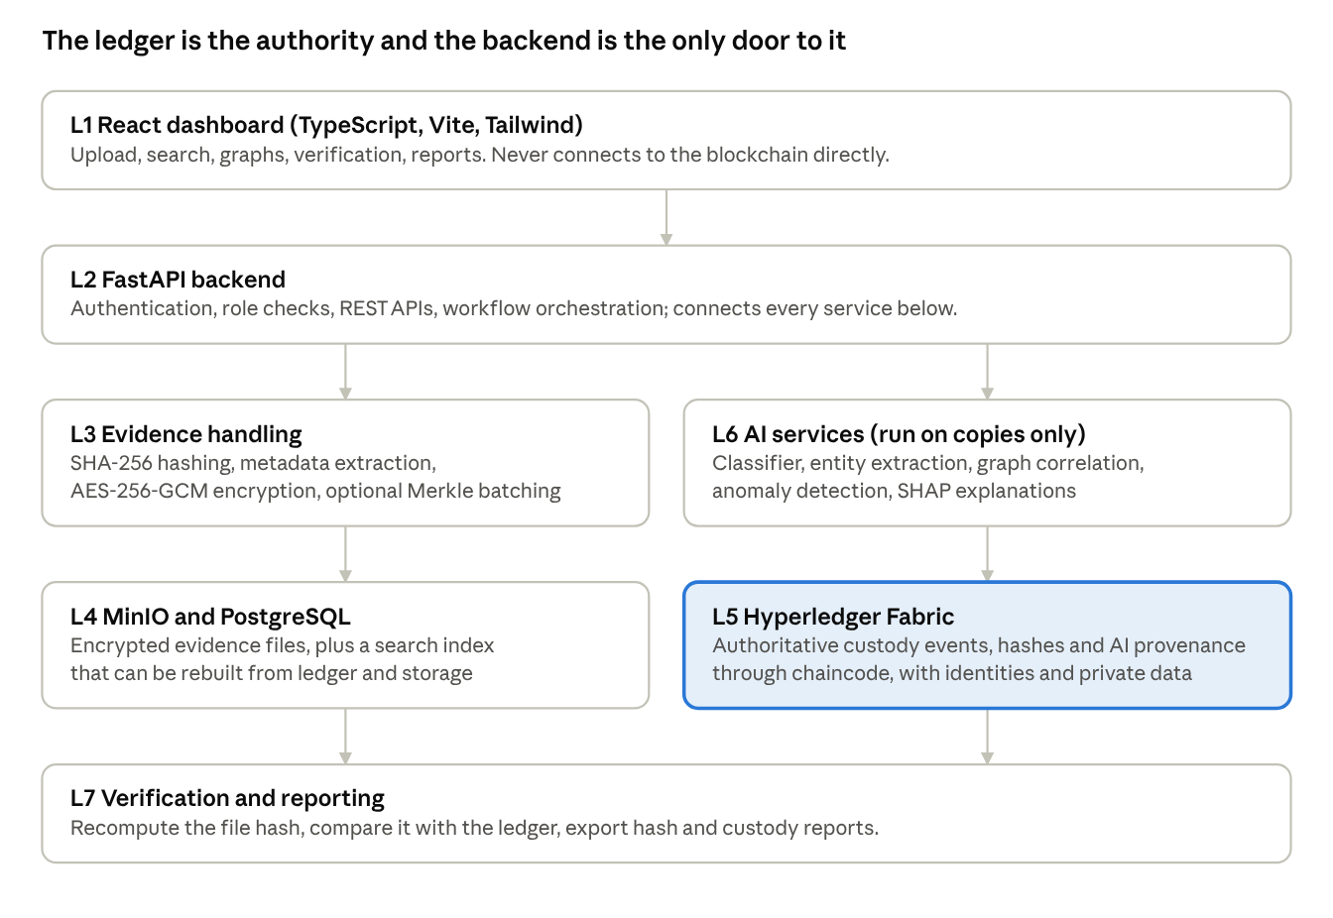
system architecture · 7 layers
Read top to bottom: requests enter through the dashboard and backend; evidence handling writes the encrypted file to storage; the ledger holds the authoritative record; verification recomputes the hash and checks it against the ledger.
Design rules
- Never put raw evidence, plaintext secrets or encryption keys on the ledger. Store the file encrypted elsewhere and anchor its hash and metadata.
- Never send encryption keys to the frontend that it does not need.
- PostgreSQL speeds up search but is not authoritative; if it is lost, evidence and custody records must be reconstructable from the ledger and storage.
- AI services read only decrypted copies, in an isolated sandbox, and only after the integrity gate passes.
- Fallback: if Hyperledger Fabric blocks progress by the end of week 5, move to a private Ethereum network (Hardhat, Ganache or Besu) rather than spending the project on infrastructure.

7. Evidence workflow and the integrity gate
No AI module may touch a file until its hash matches the ledger. This single rule keeps the AI pipeline from analysing an altered file and producing results that look legitimate.
End-to-end workflow
- Authenticate. The user signs in with a role-bound identity (multi-factor on the web layer).
- Acquire and fingerprint. The file is exported or imaged; SHA-256 is computed at the earliest possible point; metadata is captured (collector, device, tool, time, case ID).
- Encrypt and store. AES-256-GCM encrypts the file; it goes to MinIO and returns a storage reference.
- Register on-chain. Chaincode records evidence ID, hash, storage reference, metadata hash, collector, timestamp and case ID.
- Log every handling event. Transfers, accesses, downloads and analyses each create a signed ledger event.
- Integrity gate. Before any AI run, recompute the hash and compare it with the ledger.
- Run AI. Classification, entity extraction, correlation and timeline construction run on a copy.
- Anchor the AI result. Record input hash, model ID and version, configuration hash, output hash, confidence and timestamp on the ledger.
- Human review. An analyst accepts or rejects with a comment; that decision is recorded too.
- Monitor behaviour. The anomaly detector scores custody events and raises alerts.
- Verify at any time. Any authorised party can recompute the hash and obtain a ledger proof.
- Seal and report. At case close the case is sealed and the chain-of-custody and hash reports are exported.
The integrity gate, case by case
Check result | System behaviour
Hashes match | AI workflow continues; a verification event is logged
Hashes differ | AI processing is blocked, the verification failure is recorded on the ledger, evidence status becomes Failed Integrity, an alert goes to an authorised user
AI design rules
- AI runs only on copies, after the gate passes, and never changes originals.
- Every output is a lead, not a finding.
- Every output is hashed and anchored with model version and parameters.
- Human review is mandatory before an AI result appears in a report.

8. Blockchain design
A permissioned network is the right fit because participants (police, forensic lab, prosecution, court, auditors) are known and the data is sensitive. Hyperledger Fabric is the preferred platform, with Go for chaincode; private Ethereum is the fallback. The blockchain and backend teams must agree early on exactly which fields go on-chain.
On-chain evidence record (proposed)
Field | Description
evidenceId, caseId | Unique evidence identifier and case reference
fileHash, hashAlgorithm | SHA-256 (or stronger) fingerprint and the algorithm name, needed for Section 63(4)
storageRef | Reference to the encrypted file in MinIO (or an IPFS CID)
metadataHash | Hash of acquisition metadata (device, tool, location, collector)
collectorId, currentCustodian | Identities from Fabric's identity service
status | Registered, In analysis, Sealed, Flagged
timestamp, txId | Time and transaction reference
custodyEvents[] | Ordered events: type, actor, time, reason, previous event hash
aiRecords[] | Model ID, version, config hash, input hash, output hash, confidence, reviewer decision
Chaincode functions
Function | Purpose | Who may call it
RegisterEvidence | Create the on-chain record | Investigator
TransferCustody | Hand evidence to another custodian with a reason | Current custodian
LogAccess | Record a view, download or analysis | Authorised roles
VerifyIntegrity | Compare a hash with the ledger and record the result | Any authorised role, including auditor
AnchorAIResult | Store AI provenance | AI service identity
ReviewAIResult | Record the human accept or reject decision | Analyst
FlagAnomaly | Record a custody alert from the anomaly detector | AI service identity
SealCase | Lock further changes and finalise the custody record | Prosecutor or court role
GetHistory, GetProof | Return ordered history or an inclusion proof | Authorised roles
Fabric features to use: MSP identities for roles, channels to separate law-enforcement, forensic and judicial workflows, private data collections for sensitive metadata. Keep the chaincode surface small and review it for common contract errors.

9. AI modules
The AI is several small, focused services, not one large model. Build M1 to M4 as the core; M5 is a stretch goal only. Start with traditional machine-learning baselines before any deep model.
Module | Task | Methods | Output | Metrics
M1 Classification and triage | Assign categories and prioritise files. First version: phishing versus benign email | TF-IDF with logistic regression or SVM as baseline; DistilBERT or similar only if time allows | Predicted category, confidence, tags | Accuracy, precision, recall, F1, confusion matrix, inference time
M2 Entity extraction and correlation | Extract people, organisations, emails, IPs, URLs, dates; link items that share identifiers; build a timeline | spaCy NER, regex for structured identifiers, NetworkX graph; embedding similarity if needed | Relationship graph, connected evidence, event timeline | Entity F1, link precision and recall, analyst-rated usefulness
M3 Custody anomaly detection | Flag unusual access and transfer patterns | Rules, then Isolation Forest (or autoencoder) on time of day, access frequency, role-action mismatch, transfer speed | Risk alerts with reasons | Detection rate on injected misuse, false-alarm rate, rules versus hybrid
M4 Explainability and human review | Explain predictions, record version and confidence, let an analyst accept or reject with a comment | SHAP or LIME, highlighted text spans, confidence calibration | Explanation, review decision, auditable AI record | Reviewer usefulness ratings, reviewer agreement
M5 Image tamper or deepfake indicators (optional) | Flag possibly manipulated images | CNN-based detectors | Indicators for review | Only after the core system works reliably
What each AI result must carry (anchored on the ledger): model ID and version, configuration hash, input hash, output hash, confidence, timestamp, and the reviewer's decision.
Screens that depend on these modules: AI Analysis Results (M1, M2, M4), Relationship Graph (M2), Security and Anomaly Alerts (M3), Dashboard KPIs for AI Analysed and Security Alerts.
Notes for the team
- The mock-up shows a model named BERT-Phishing-Classifier v1.2. The suggested plan builds the TF-IDF baseline first and moves to a transformer only if needed; use whichever you actually ship in the Model Information card.
- The study document's target of F1 of 0.85 or higher is a working goal to adjust to the dataset, not a guaranteed outcome.
- Network-intrusion classification (CIC-IDS2017) and malware features (EMBER) are optional extensions; adding them alongside email analysis, anomaly detection and image forensics risks scope creep.

10. Datasets
Use public or synthetic data only. Never use real police case data or real personal data. Do not wait for large downloads: build and test the upload, hashing, encryption, ledger and reporting workflow with synthetic files first, then add the AI datasets. Licences and sizes below come from the plan and must be checked before download.
Dataset | Purpose | Priority | Size note
Synthetic evidence files (you create 10 to 20: TXT, EML, CSV, JSON, images) | Hash and upload testing | Essential, do first | Tiny
Synthetic chain-of-custody events (you generate CSV or JSON with Python, with labels for normal and misuse) | Train and test M3: late-night bulk downloads, rapid transfers, repeated failed checks | Essential | None to download
NIST CFReDS reference sample | Documented forensic test scenarios and hash verification | Download a small one first | Varies; some disk images are large
One labelled phishing email dataset (public) | M1 classification with a fixed, documented train and test split | Required for M1 | Check the chosen download
Enron email corpus subset | M2 entity extraction, relationship graph, timelines | Recommended | Full corpus about 500,000 emails (about 1.7 GB compressed); start with a few thousand messages
CIC-IDS2017 (selected labelled CSVs only) | Optional network-flow classification and anomaly experiments | Optional second stage | Daily captures are about 7.8 to 13 GB each; avoid the PCAPs
EMBER feature data | Optional malware classification from static features, no live samples | Optional | Use a subset or skip
Important cautions
- The Enron corpus is not labelled for phishing. Do not treat every Enron email as benign; use it for entity extraction and graphs, and use the separate labelled phishing dataset for classification.
- Handle malware or illicit-content material only as feature datasets or clearly synthetic stand-ins, in an isolated environment.
- Record each dataset's version, licence and split in a model card.

11. Technology stack
This is the stack the plan recommends to keep a student prototype manageable. The study document lists alternatives, so none of it is mandatory.
Component | Recommended | Alternative | Why
Frontend | React, TypeScript, Vite, Tailwind CSS, a charting library, a graph and timeline visualisation library | Streamlit for quick demos | Matches the multi-page dashboard in the mock-up
Backend | Python with FastAPI | Node.js, Spring Boot | Easy bridge between the frontend and Python AI libraries
Blockchain | Hyperledger Fabric, chaincode in Go | Private Ethereum with Solidity (Hardhat, Ganache or Besu) | Permissioned network, identities, channels, private data; Ethereum is simpler to start
Evidence storage | MinIO with AES-256-GCM | Private IPFS (add later if time allows) | MinIO is far simpler to operate
Database | PostgreSQL | MongoDB | Search and filtering index only; the ledger stays authoritative
AI and ML | scikit-learn, spaCy, SHAP; add PyTorch or Hugging Face only when needed | TensorFlow | Useful models without training large ones
Relationship graph | NetworkX | Neo4j or Memgraph if a persistent graph is needed | Build and query evidence relationships
Development | Docker Compose, GitHub | Kubernetes (not needed) | Reproducible environment and shared code
Integration contracts to agree in week 1 to 2
- The JSON response formats between the frontend team and the AI team.
- The exact on-chain fields between the blockchain team and the backend team.
- Role names and permissions, shared by the backend, chaincode and UI.
- Evidence statuses and alert severities, which the UI already fixes: Verified, Under Review, Flagged, Failed Integrity; Critical, High, Medium.

12. Security controls and threat model
Controls to build in
- Role-based access control tied to Fabric MSP identities; multi-factor authentication on the web layer.
- TLS everywhere; per-case encryption keys wrapped by a key-management service; never store keys on-chain.
- Signed transactions for non-repudiation; separate identities for human users and the AI service.
- Sandboxed AI execution on copies, with every model run logged.
- Smart-contract review and tests; documented consensus and node-security configuration.
Threat model
Threat | Example | Control
Tampering with evidence | Insider edits a file in storage | Hash on-chain; integrity gate and verification detect the mismatch
Tampering with records | Attempt to alter or delete custody entries | Immutable ledger, consensus, signed transactions
Spoofing | Using another user's credentials | Fabric identities, MFA, role-bound permissions
Repudiation | User denies having accessed evidence | Signed access events on the ledger
Information disclosure | Leak of evidence content or keys | Encryption, access control, private data collections, key management
Denial of service | Overloading nodes or the API | Rate limiting, redundant peers, monitoring
Wrong or fake registration | Registering a wrongly collected file | Signed acquisition metadata, documented procedure, human review; state the limitation openly
Smart-contract flaws | Logic bugs or privilege errors | Code review, tests, minimal chaincode surface
Consensus attacks | 51 percent or Sybil attacks | Permissioned membership and known validators
AI-specific attacks | Adversarial inputs, poisoned training data | Model version control, input validation, anchored model records, human review
Model unreliability | Wrong or biased classification | Calibrated confidence, explanations, human gate, reported error rates

13. Evaluation plan
A working UI alone is not enough proof. Nine experiments show the system works; each produces a table or graph for the final report.
ID | Experiment | Method | Measure
E1 | Tamper detection | Change file bytes, metadata, storage reference; replay or reorder custody events; attempt log deletion; then verify | Detection rate, false-alarm rate
E2 | Registration and verification performance | Vary file size (about 1 MB to 1 GB) and event counts; time hash, encrypt, upload, commit, verify | Latency (median and 95th percentile), throughput
E3 | Baseline comparison | Same workload on a conventional database plus log file versus the blockchain design | Overhead and security benefit
E4 | AI classification | Held-out split and cross-validation; baseline versus advanced model | Precision, recall, F1, confusion matrix
E5 | Evidence correlation | Label a sample of relationships; compare with predicted links | Link precision and recall, timeline accuracy
E6 | Anomaly detection | Inject after-hours bulk access, role abuse and rapid transfers into synthetic logs | Detection and false-alarm rates, rules versus hybrid
E7 | AI reproducibility | Re-run recorded model on recorded input | Whether the output hash is reproduced
E8 | Explainability review | Small panel (team or mentors) rates explanations | Usefulness ratings and agreement
E9 | Security review | Test roles, permissions, common contract errors | Findings and fixes
Hypotheses these test
- H1: every modification of a file, its metadata or its ledger reference is detected, with no false alarms on untouched evidence.
- H2: ledger growth tracks the number of events, not file size.
- H3: a rule-plus-ML detector finds more simulated misuse than rules alone at an acceptable false-alarm rate.
- H4: re-running a recorded model on a recorded input reproduces the anchored output hash.
Success criteria (to finalise with the supervisor)
Area | Criterion
Integrity | All tamper scenarios detected; zero false alarms on unmodified evidence
Custody | Complete, ordered, signed history for every item; role rules enforced
Performance | Latency, throughput and verification time reported against file size and event count, with overhead versus baseline
AI quality | Classification F1 reported (working target 0.85 or higher, adjusted to the dataset); correlation precision measured on a labelled sample
AI provenance | Re-run reproduces the anchored output hash
Anomaly detection | Hybrid detects more simulated misuse than rules alone, with false-alarm rate reported
Usability and reporting | Reviewers can explain AI results from the dashboard; reports generate without manual hash editing
Test at growing scales to show trends and explain how the hybrid design would scale; do not claim production scale.

14. Roadmap, team and risks
The 14-week plan has seven phases. Prioritise a working end-to-end product over implementing every feature; the single hard decision point is the end of week 5.
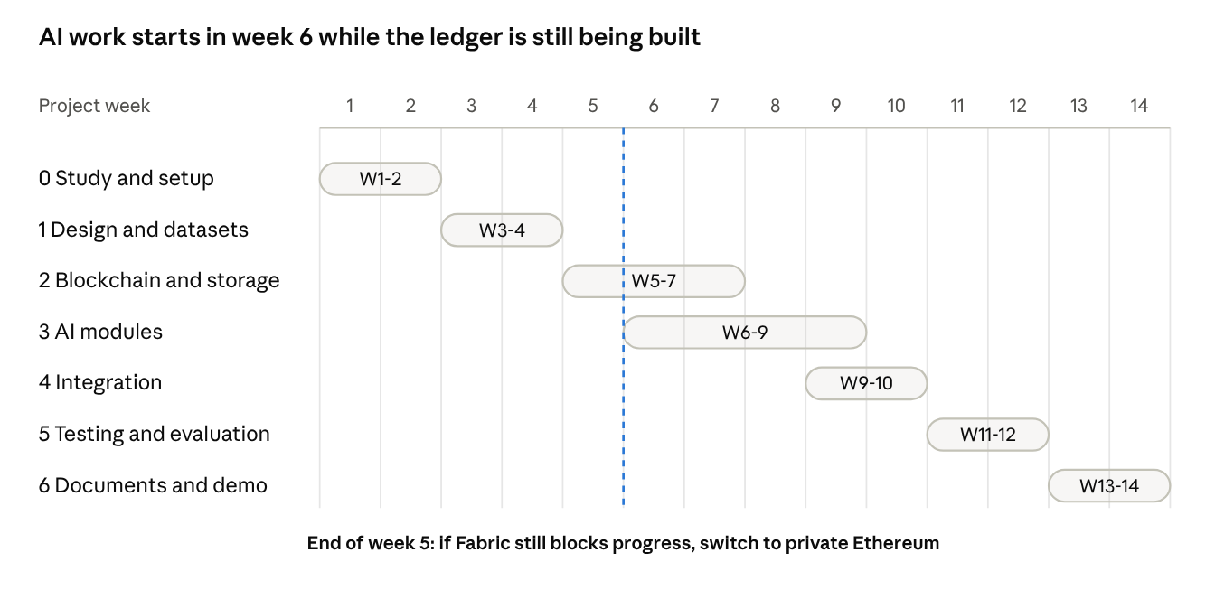
14-week roadmap · 7 phases, 1 decision point
Phase | Main work | Exit check
0 Study and setup | Read key papers, confirm scope and open decisions, create the repository and environment | Team can answer the readiness questions in section 15
1 Design and datasets | Database schema, API contracts, role permissions, dashboard pages, AI data pipeline, initial React screens | Signed-off design and dataset list
2 Blockchain and storage | Fabric network, chaincode, hashing, encryption, MinIO, registration, transfer, access logging, verification | Upload, register, transfer and verify a file end to end
3 AI modules (parallel) | Classifier, entity extraction, relationship graph, synthetic custody anomaly detector, explanations | Working models with metrics on held-out data
4 Integration | Connect React, FastAPI, ledger, storage and AI; human review; provenance records; reports | Complete investigation demo from upload to report
5 Testing and evaluation | Tamper, access-control, model quality, performance, false-alarm and reproducibility tests | Evaluation tables, graphs, security review
6 Documents and demo | Project report, presentation, diagrams, limitations, results, demo scenario | Submission-ready prototype
Three milestones
- A trustworthy evidence system: dashboard and authentication, upload with metadata, SHA-256 and AES-256-GCM, MinIO plus Fabric custody records, transfer history, integrity verification, basic reports. Goal: show that changes to registered evidence are detected and custody is auditable.
- AI-assisted investigation: one labelled classifier, entity extraction, evidence graph, synthetic anomaly detection, explanations with mandatory human review, AI provenance on the ledger. Goal: show useful leads with an explanation of how they were produced.
- Evaluation and final product: complete role-based dashboard, reports and case sealing, tamper and security tests, AI quality and performance evaluation, final documentation and demo. Goal: a reproducible research prototype, not only a presentable UI.
Team roles (adapt to team size)
Role | Main responsibility
Blockchain and backend lead | Fabric, chaincode, APIs, storage integration
AI and ML lead | Datasets, models, evaluation, AI explanations and model records
Security and verification lead | Hashing, encryption, access control, tamper tests, reports
Frontend and documentation lead | React dashboard, visualisations, report templates, legal and standards mapping
Every member should understand the entire workflow. The frontend and AI roles must agree API response formats early.
Project risks
Risk | Mitigation
Fabric setup takes too long | Start early with the official test network; use the week-5 fallback to private Ethereum
Scope creep from too many AI modules | Core is M1 to M4; M5 is a stretch; freeze scope at the end of design
Dataset does not match the evidence types | Choose datasets early, define a narrow labelled task, report limits honestly
Poor performance with large files | Chunk files, stream hashing and encryption, test early with growing sizes
Key management mistakes | Explicit key design; never store keys on-chain
Over-claiming legal value | State that the system supports, but does not replace, certificates, experts and procedure
Team knowledge gaps | Finish the readiness checklist before coding

15. Legal, standards and research context
This section is what every team member must study before coding. It is drawn from the original study document, which was based on web research in October 2026; verify legal points and figures against primary sources before citing them in the final report. This is not legal advice.

15.1 Core concepts to be comfortable with
Concept | Plain meaning | Role here
Chain of custody | Unbroken record of who collected, held, moved, accessed and analysed evidence | The record we make tamper-evident
Integrity vs authenticity | Integrity: unchanged since a reference point. Authenticity: it is what it claims to be | Blockchain secures integrity after registration; authenticity depends on good acquisition and signed identities
SHA-256 hash | One-way fingerprint; change one bit and it changes completely | Fingerprint of files, metadata and AI outputs
Merkle tree | Many hashes summarised into one root with short proofs | Optional batch anchoring
Permissioned blockchain, chaincode, consensus | Only approved participants join; chaincode enforces rules; nodes agree on the next block | Custody ledger on Hyperledger Fabric
Off-chain storage | Large files stored outside the chain; only hash and location on-chain | Encrypted evidence in MinIO
AES-256-GCM, PKI | Encryption with integrity check; signatures prove who acted | Confidentiality and non-repudiation
NER, correlation, knowledge graph | Extract entities and link items sharing them | Module M2
Anomaly detection | Flag behaviour unlike the norm | Module M3
Explainable AI, human-in-the-loop | Show why a model answered; a person approves AI output | Module M4; mandatory review gate

15.2 Standards and Indian law
- ISO/IEC 27037 covers identification, collection, acquisition and preservation of digital evidence. Map workflow stages to it. Related background: ISO/IEC 27041, 27042, 27043 and NIST SP 800-86; confirm scope before citing.
- Bharatiya Sakshya Adhiniyam (BSA), 2023, Section 63 replaced the Indian Evidence Act's Section 65B from 1 July 2024. Section 63(4) requires a certificate in the prescribed format with two signatories (the person responsible for the device or record, and an expert) and the hash value with the hash function used. Use SHA-256 or stronger; MD5 is weak against collisions.
- The Supreme Court of India upheld the validity of Section 63(4) and described the hash value as an electronic fingerprint. A June 2026 law-firm note says the ruling addresses who may sign the expert part. Team action: read the judgment or the cited note before finalising the certificate-support feature.
- A certificate only gets a record admitted; it does not prove authenticity, and the certifying expert can be cross-examined.
- What our system does: compute and store the hash early, keep a verifiable handling history, and generate hash and custody reports with Section 63(4) field mapping. What it does not do: issue a legally sufficient certificate, guarantee court acceptance, or replace the expert.
- AI and privacy: AI outputs are leads, never conclusions. The EU AI Act treats forensic and law-enforcement AI as high risk with human oversight (a benchmark, not Indian law). India's Digital Personal Data Protection Act, 2023 may affect personal data in evidence; the prototype avoids real personal data entirely.

15.3 Research gaps this project addresses
Gap | Our response
G1 Few fully integrated, evaluated blockchain and AI custody systems | Build and evaluate one unified prototype
G2 AI outputs are rarely provenance-tracked | Anchor every AI result with model, version, input and output hashes, confidence, reviewer
G3 Hybrid on-chain and off-chain storage is under-evaluated | Implement encrypted off-chain storage and measure it
G4 Limited performance comparison with traditional databases | Benchmark latency, throughput and verification time (E2, E3)
G5 Privacy and retention conflict with immutability | Encrypt off-chain, store only hashes and metadata on-chain, role-based access
G6 Blockchain evidence systems rarely tied to BSA Section 63(4) | Reports mapped to Section 63(4) fields and ISO/IEC 27037 stages
G7 Explainability and admissibility of AI forensic output | Explanations, calibrated confidence, human review, reproducible records
G8 Blockchain secures evidence only after registration | Hash at source, signed acquisition metadata, documented procedure
G9 Fixed smart-contract rules cannot spot subtle insider misuse | Anomaly detector over custody events
G10 No standard evaluation practice | Publish metrics, datasets and a tamper-test protocol

15.4 Recommended reading order
- Bonomi et al., B-CoC: an early, concrete Ethereum-based custody prototype.
- A recent systematic review of blockchain chain of custody (Ponte Cuevas and Huaman Aguirre, 2025, or the ISO 27037 mapping review).
- Jeong et al. (2020), the Hyperledger Fabric digital-evidence model.
- ForensiBlock and the Edinburgh Napier Fabric plus IPFS architecture, for storage, scale and provenance.
- Amintoosi et al., machine learning in digital forensics, and the AI evidence-triage review.
- The Research Square blockchain and AI chain-of-custody preprint (not peer-reviewed; read critically).
- The AI admissibility analysis (arXiv 2026) and Solanke's explainable digital-forensics work.
- BSA 2023 Section 63 notes and the Supreme Court judgment summary on Section 63(4).
Full reference links are in the original study document, section 17.

15.5 Readiness questions
You are ready to code when every member can answer these:
- What is chain of custody, and why does a broken chain weaken evidence?
- What does a hash prove, and what does it not prove?
- Why is the hash on-chain but the file off-chain?
- Why a permissioned rather than a public blockchain?
- What does each chaincode function do, and who may call it?
- Which AI tasks are in scope, and why are outputs leads and not conclusions?
- How is an AI result made auditable on the ledger?
- What does Section 63(4) ask for, and what does our report do and not do about it?
- Which research gaps do we address, and how will experiments E1 to E9 prove the system works?

16. Prompt-book blueprint and open decisions
The prompt book should be built as 18 ordered build units. Each unit becomes one or more prompts, and each prompt should attach this document and the UI image. This is a proposed split; reorder it to match your team.
Unit | Builds | Depends on | UI screens | Done when
P0 Repository and environment | Monorepo layout, Docker Compose for FastAPI, PostgreSQL, MinIO, Fabric or fallback | None | None | All services start with one command
P1 Data model and API contracts | PostgreSQL schema, REST endpoints, JSON formats, role matrix, on-chain field list | P0 | None | Contracts approved by all four roles
P2 Authentication and roles | Login, MFA, role-bound sessions, permission checks | P1 | Login (to design) | Each role sees and does only what section 4 allows
P3 Evidence handling service | SHA-256 streaming hash, AES-256-GCM encrypt and decrypt, MinIO storage, key handling | P1 | None | A file round-trips and the hash matches
P4 Blockchain layer | Fabric network, chaincode (RegisterEvidence, TransferCustody, LogAccess, VerifyIntegrity, SealCase, GetHistory), backend gateway; private Ethereum if the week-5 fallback triggers | P1 | None | Register, transfer and verify work on the ledger
P5 Evidence APIs | Upload, register, transfer, log access, verify, history, search | P2, P3, P4 | None | End-to-end API flow passes tests
P6 Frontend foundation | Design tokens, sidebar and top bar shell, status chips, landing page, auth pages | P2 | 1 Landing; Login | Shell matches the mock-up
P7 Frontend core screens | Dashboard, Case Management, Evidence Upload wizard, Evidence Details, Chain of Custody | P5, P6 | 2, 3, 4, 5, 8 | Upload to verified view works from the browser
P8 Synthetic data | Generators for sample evidence files and labelled custody events | P1 | None | Datasets saved with a documented schema and labels
P9 M1 classification | Phishing classifier baseline, metrics, model card | P8 and chosen dataset | AI Analysis (part) | F1 and confusion matrix reported
P10 M2 entities and graph | NER, identifier regex, NetworkX graph, timeline | P8, Enron subset | Relationship Graph data | Entities and links returned for sample cases
P11 M3 anomaly detection | Rules plus Isolation Forest on custody events | P8 | Alerts data | Detection and false-alarm rates reported
P12 M4 explainability, review and anchoring | SHAP or highlights, review accept or reject, AnchorAIResult and ReviewAIResult | P4, P9 | Review dialog | Re-run reproduces the output hash
P13 AI screens | AI Analysis Results, Relationship Graph, Security and Anomaly Alerts | P9 to P12, P6 | 6, 7, 9 | Screens show live model output
P14 Reports | Evidence, custody, AI analysis and case summary PDFs; Section 63(4) field mapping | P5, P12 | 10 Reports and Export | Reports generate without manual hash editing
P15 Integration | Integrity gate in front of every AI run, failed-integrity state, case sealing, Users and Roles, Settings | P5, P12, P13 | Failed-integrity states; Users and Roles; Settings | Tampered file blocks AI and raises an alert
P16 Testing and evaluation | Scripts and reports for E1 to E9 | P15 | None | Tables and graphs for the final report
P17 Documentation and demo | Report, presentation, diagrams, demo script | P16 | All | Demo scenario from section 3 runs end to end
What every prompt should state
- Attach this document, the UI image, and the relevant section numbers.
- Restate the rules: no raw evidence, secrets or keys on the ledger; the frontend never talks to the blockchain; AI runs on copies after the integrity gate; AI outputs are leads reviewed by a human; no real personal data.
- Name the exact inputs, outputs, file paths and tests expected, and the screen number from section 5.
Decisions to settle in the first two weeks
Item | Options | Suggested default
Blockchain platform | Hyperledger Fabric or private Ethereum | Fabric; fall back to Ethereum if blocked by the end of week 5
Evidence storage | MinIO or private IPFS | MinIO first; IPFS only if time allows
First AI task | Phishing email classification, log or intrusion classification, mixed triage | Phishing email classification with one labelled public dataset
Second AI task | Entity extraction and graph; intrusion classification | Entity extraction and relationships on an Enron subset; network intrusion only if genuinely needed
Anomaly detection | Rules only or rules plus ML | Generate synthetic custody logs; compare rules against Isolation Forest
Optional AI | M5 image or deepfake detection | Defer until the core works
Legal-support depth | Hash report only or full Section 63(4) field mapping | Field mapping plus hash report; no legal-advice claims
Classifier model in the UI | TF-IDF baseline or BERT-style model (the mock-up shows BERT) | Baseline first; show the model actually shipped
Team size and calendar | Unknown | Confirm, then adjust the roadmap
Mentor expectations | Prototype only, or paper and publication | Confirm; affects evaluation depth
The "18" on the project sheet row | Unknown meaning (the heading was not visible) | Ask the project coordinator what it denotes
Each unit above becomes one section of the final prompt book.

